# KiCAD Component Library

# Scope

This document should be a general guide for common setup of KiCAD component library supporting

PCB design process.

# Overview

The component library in general consits of two parts a schematic symbol and a footprint.

The schematic symbol also contains attributes like: ordering information, description and the assigned footprint.

All parts created for the library are created first in a temporary location ( project library ) and are transfered before official releasing project data.

# Symbol

To draw and edit a symbol we are using "Symbol library editor".

The two examples below are a good example for the two most important symbol design rules.

1. **Atomic Parts**

Atomic parts fully define a component, specifying a matching footprint, and are named based on the MPN (manufacturer part number).

Atomic parts are ready to be placed onto the PCB as they are already associated with a footprint.

1. **Pin transparency**

Pin transparency means all pins, pads a physical component have should be shown on the schematic even if they have no function

like test pins or non connected pins.

1. **Symbol name**  
   The symbol name must be unique and follow the manufacturer name or product series. For passive components the component  
   can be also named like: "value+ManufacturerSeries+footprint".
2. **Field properties**

Every schematic symbol has field with attributes which belong to the symbol.

1. **Pin numbering/naming**  
   Pin numbering and naming need to follow the component manufacturer datasheet. If a component  
   has alternative pin function there can be also 2 symbol for one component (I2C/SPI).

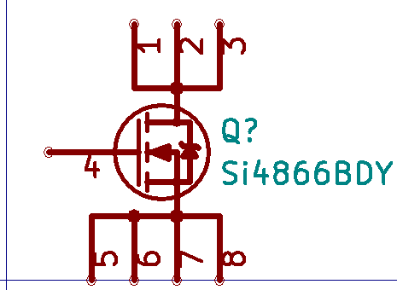 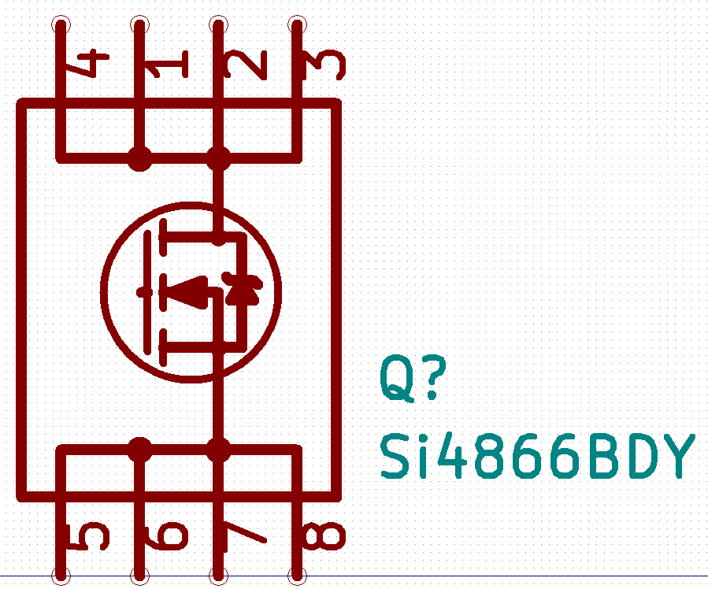 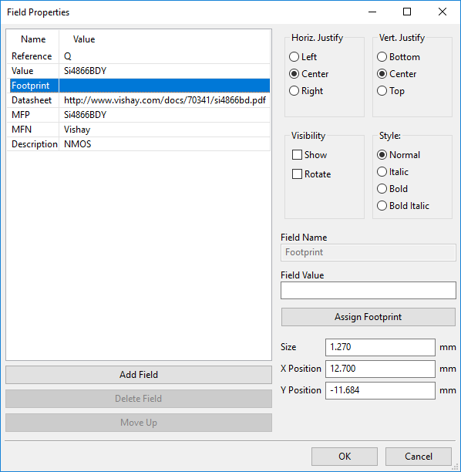

**Field properties**

Every component symbol need to have the properties below.

| Field name | Value | Visible  (Schematic) |
| --- | --- | --- |
| Reference | Component reference.  Shown in schematic & BOM | Show |
| Value | Component value shown on  the schematic. | Show |
| Footprint | Footprint which is assigned to the  component. Used for layout. | Hidden |
| Datasheet | Online resources for the component  can be opened in schematic. | Hidden |
| Description | Unique description which will appear  in the BOM list. | Hidden |
| MFN | Manufacturer Name  shown in the BOM. | Hidden |
| MFP | Manufacturer part number  shown in the BOM. | Hidden |

## Designators / Library

In a Kicad component library there are several file types involved for symbol and footprint library.

The list below show how to identify library related files.

| Library file type | Description | Note |
| --- | --- | --- |
| .lib | Symbol library file | .lib & .dcm are corresponding and **case sensitive!** |
| .dcm | Symbol library file | .dcm & .lib are corresponding and **case sensitive!** |
| "Folder name".pretty | Footprint library folder | A folder name with the ending .pretty |
| .kicad_mod | Footprint file | The footprint file is part of the ".pretty" footprint folder library |

The list below of designators is recommended to use in schematic projects we organize our component library in

the same categories as the designators.

| Designator | Component Type | Symbol library | Footprint folder |
| --- | --- | --- | --- |
| A | Sub-assembly or plug-in module | module.lib / module.dcm | module.pretty |
| AE | Antenna | antenna.lib / antenna.dcm | antenna.pretty |
| BT | Batteries all kind of chemistries | battery.lib / battery.dcm | battery.pretty |
| C | Capacitor, stacked capacitors, supercaps etc | capacitor.lib / capacitor.dcm | capacitor.pretty |
| D | Diode | diode.lib / diode.dcm | diode.pretty |
| DS | Display and display subassemblies | display.lib / display.dcm | display.pretty |
| F | Fuse, circuit protection components | fuse.lib / fuse.dcm | fuse.pretty |
| FB | Ferrite bead, ferrite rods etc | ferrite.lib / ferrite.dcm | ferrite.pretty |
| FD | Fiducial & Markings | fiducial.lib / fiducial.dcm | fiducial.pretty |
| FL | Filter components | filter.lib / filter.dcm | filter.pretty |
| H | Hardware (mounting screws, mechanical parts soldered on PCB) | hardware.lib / hardware.dcm | hardware.pretty |
| J | Jack, fixed part of a connector pair soldered to the pcb | jack.lib / jack.dcm | jack.pretty |
| JP | Jumper / link (for engineering purposes/manufacturing) | jumper.lib / jumper.dcm | jumper.pretty |
| K | Relay, Contactor | relay.lib / relay.dcm | relay.pretty |
| L | Inductor, coil, air coil, ferrite coil, coupled inductors | inductor.lib / inductor.dcm | inductor.pretty |
| LS | Loudspeaker or buzzer (audio generators) | loudspeaker.lib / loudspeaker.dcm | loudspeaker.pretty |
| M | Motor (also linear motors) | motor.lib / motor.dcm | motor.pretty |
| MK | Microphone | microphone.lib / microphone.dcm | microphone.pretty |
| Q | Transistor (bipolar,MOSFET,IGBT etc.) | transistor.lib / transistor.dcm | transistor.pretty |
| R | Resistor | resistor.lib / resistor.dcm | resistor.pretty |
| RN | Resistor network | resistornetwork.lib / resistornetwork.dcm | resistornetwork.pretty |
| RT | Thermistor | thermistor.lib / thermistor.dcm | thermistor.pretty |
| RV | Varistor | varistor.lib / varistor.dcm | varistor.pretty |
| SW | Switch | switch.lib / switch.dcm | switch.pretty |
| T | Transformer | transformer.lib / transformer.dcm | transformer.pretty |
| TC | Thermocouple | thermocouple.lib / thermocouple.dcm | thermocouple.pretty |
| TP | Test point | testpoint.lib / testpoint.dcm | testpoint.pretty |
| U | Integrated circuit (IC) | ic.lib / ic.dcm | ic.pretty |
| Y | Crystal / oscillator / VCO etc. | crystal.lib / crystal.dcm | crystal.pretty |
| Z | Zener diode | zener.lib / zener.dcm | zener.pretty |

## Grid settings

All Symbol pins should be drawn in a 100mil grid so that it fits the schematic grid of 50mil.

| Purpose | Grid |
| --- | --- |
| Pin placement | 100mil |
| Graphic | any |

# Land pattern

Although, in many instances, the land pattern geometries can be different based on the type of soldering used to attach the electronic part, wherever possible,

land patterns are defined with consideration to the attachment process being used. Whether parts are mounted on one or both  
sides of the board, subjected to wave, reflow, or other type of soldering, the land pattern and part dimensions should  
be optimized to insure proper solder joint and inspection criteria.

**Land pattern density levels defined by IPC-7351:**

**Density Level A:** Maximum (Most) Land Protrusion –  
For low-density product applications, the ‘maximum’ land pattern condition has been developed to accommodate  
wave or flow solder of leadless chip devices and leaded gull-wing devices. The geometry furnished for these  
devices, as well as inward and ‘‘J’’-formed lead contact device families, may provide a wider process window for  
reflow solder processes as well.

**Density Level B**: Median (Nominal) Land Protrusion –

Products with a moderate level of component density may consider adapting the ‘median’ land pattern geometry.

The median land patterns furnished for all device families will provide a robust solder attachment condition for reflow

solder processes and should provide a condition suitable for wave or reflow soldering of leadless chip and leaded  
gull-wing type devices.

**Density Level C:** Minimum (Least) Land Protrusion –  
High component density typical of portable and hand-held product applications may consider the ‘minimum’ land pattern  
geometry variation. Selection of the minimum land pattern geometry may not be suitable for all product use  
categories.

It is highly recommended to use automated tools which are IPC-7351 compliant to create footprints. These tools or scripts calculate

land patterns based on approved algorithms.

## Land pattern layer

The table below describes the layers which are set up by default in Kicad ( 2 Layer ).

Layers can be grouped by purpose into 3 groups: Fabrication layer, Documentation layer.

Fabrication layer are the one which will send out to the PCB manufacturing and are the main design layer.

These are used for copper etching, printing screens and to cut masks.

Documentation layer are used for assembly drawings and design data exchange.

| Layer | Description | Type | Note |
| --- | --- | --- | --- |
| F.Cu | Top layer signal | copper | Mandatory layer for production  files (surface mount) |
| B.Cu | Bottom layer signal | copper | Layer for production files |
| F.Adhes | Top layer adhesive layer | adhesive | Only use for wave soldering |
| F.Paste | Top layer solder paste. | solder paste | For reflow soldering. |
| F.SilkS | Top layer printing | silk screen | Component designator printing.  Text should be limited to component designators. |
| F.Mask | Solder mask opening for pads, via etc. | solder mask | Drawn area is NOT covered with  solder mask |
| F.CrtYd | Visual support for component placement | mechanical | Not related to production data |
| F.Fab | Top layer  Component outline for documentation | mechanical | Used to create assembly drawing.  Not related to production process.  Text should be limited to component designators. |

# References

* Component library editor: [http://docs.kicad-pcb.org/stable/en/eeschema.html#component-library-editor](http://docs.kicad-pcb.org/stable/en/eeschema.html" \l "component-library-editor)